Harworth & Bircotes Neighbourhood Development Plan
The Environmental Assessment of Plans and Programmes Regulations 2004
SEA Screening Statement
Introduction
The requirement for a Strategic Environmental Assessment to be undertaken on development plans and programmes that may have a significant environmental effect is outlined in European Union Directive 200142/EC. The Environmental Assessment of Plans and Programmes Regulations 2004 (the Regulations) state that this is determined by a screening process, utilising a specified set of criteria which is outlined in Schedule 1 of the Regulations. The results of this process must be set out in an SEA Screening Statement, which must be publicly available.
As the responsible authority under Regulation 9 of the SEA Regulations 2004, Harworth & Bircotes Town Council have produced this Screening Assessment and consequentially do not believe that the Draft Harworth & Bircotes Neighbourhood Development Plan (NP) in its current form will have any significant negative effects on the environment. We are therefore are of the belief that a full environmental assessment is not necessary. This determination has been reached by assessing the contents of the Draft NP against criteria provided in Schedule 1 of the 2004 Regulations.
Harworth & Bircotes Neighbourhood Development Plan
The Harworth & Bircotes Neighbourhood Development Plan has been produced by Harworth & Bircotes Town Council with the aid of local residents; it plans for the future development and growth of the area up to the year 2028. The NP covers the designated Harworth & Bircotes neighbourhood area as seen on Figure 1 below.
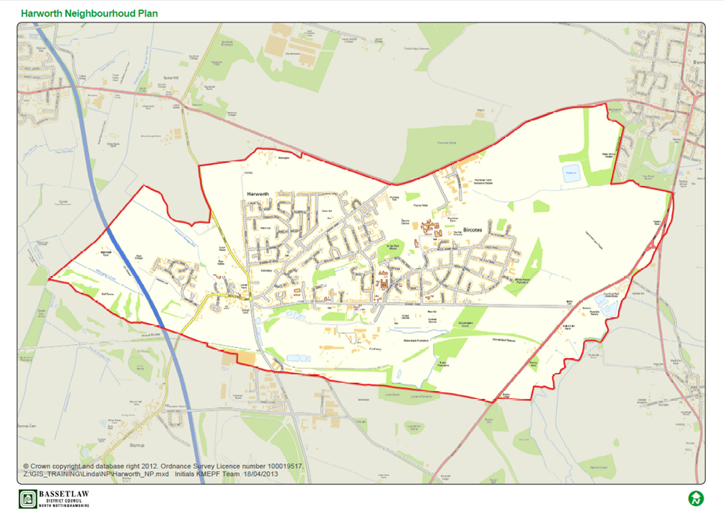
The main priorities of the Harworth & Bircotes NP are expressed throughout the Plan, most clearly in its Vision, Aim and Objectives, these will be delivered in turn by the 15 Development Policies and 12 Projects contained in the NP. The Vision, Aim and Objectives of the NP can be found below.
Vision

In 20 years’ time Harworth & Bircotes will be a thriving community, a place where people are proud to live. It will be a safe and happy place, an area that values its people and its environment. It will have a variety of homes, jobs, shops, schools and recreational facilities; something for everyone. Harworth & Bircotes will be a place people want to move to.

Aim

The Neighbourhood Development Plan must take a positive approach to development so long as it brings forward a balance of housing, retail, community and leisure development to ensure Harworth & Bircotes becomes an attractive place, providing all the amenities you would expect in a desirable town. All development over the Plan period will maximise the environmental assets in and around Harworth Bircotes improving access to the countryside and open spaces for residents and visitors.

Objectives

Objective 1: To redevelop the old Colliery Site delivering a mixed use development that benefits the local community now and for years to come.

Objective 2: To sustain and regenerate the Town Centre of Harworth & Bircotes, strengthening its role as the heart of the community.

Objective 3: To develop a new footpath and cycle network linking the new and old housing developments to services and facilities in the town.

Objective 4: To encourage restaurants and cafes to locate in the area providing amenities suitable for all the family.

Objective 5: To deliver housing growth that reflects the local community’s needs and allows the town to grown sustainably.

Objective 6: To protect and enhance Harworth & Bircotes environmental assets for current and future generations.

Objective 7: To safeguard existing and provide new community facilities, open spaces and public transport.

Screening Assessment
Criteria for determining the likely significance of effects (Annex II SEA Directive) | Will the NDP have significant environmental effects | Summary of any effects
1a The degree to which the plan or programme sets a framework for projects and other activities, either with regard to the location, nature, size and operating conditions or by allocating resources. | NO | The NP will set out a spatial vision for the designated Harworth & Bircotes NP area and provides a framework for proposals for development in Harworth & Bircotes regarding the following:  - Designating a new housing site on the former contaminated colliery site within the existing development boundary of Harworth & Bircotes set out the BDC Core Strategy 2011,  - Design and tenure of new housing,  - Designation of new shopping facilities within the existing development boundary set out the BDC Core Strategy 2011  - Extension to the existing town centre boundary  - Designation of open spaces  - Improvements to existing environmental and community assets in and around Harworth & Bircotes also improving access to the countryside and open spaces for residents and visitors.  The NP is considered to be in general conformity with Bassetlaw District Councils Core Strategy 2011. It is also considered to be in general conformity with the National Planning Policy Framework (NPPF). Consideration has also been given to the emerging Preferred Options Site Allocations document, although this is subject to further changes before it reaches examination and adoption.  Several projects are included in the NP (see Appendix A) that do not directly influence development and land use. These do have regard to the Plan area but it is deemed they will not have any significant effects on the environment.
1b The degree to which the plan or programme influences other plans and programmes including those in a hierarchy. | NO | The NP, where possible, will respond to rather than influence other plans and programmes. An NP can only provide policies within the designated NP area it covers and will also provide policies to help Development Control Officers determine planning applications along with the Bassetlaw District Council Local Plan and the NPPF. None of the policies contained in the NP have a direct impact on other plans in neighbouring areas.  The NP will have some influence on the development proposed in Bassetlaw District Councils Core Strategy, and more specifically the Preferred Options Site Allocations document (see Policies 1- 15 within the plan). However as these plans are already significantly developed these likely effects of the NP can be considered as being minimal.
1c The relevance of the plan or programme for the integration of environmental considerations in particular with a view to promoting sustainable development. | NO | The NP sets out and promotes sustainable development within the NP area whilst balancing environmental, social and economic needs within the area. However, local residents have stressed the importance of having some certainty over the future development of the former colliery site. The current planning permission on the site is for outline permission for up to 996 residential units (C3),  2,044m2 convenience retail unit (A1) and 76,645m2 of employment uses (B1c, B2  and B8). The convenience retail unit has already been developed (Asda) and phase  1 of the residential development has already commenced for 118 residential units being developed by Jones Homes. The residents within the area do not want to see the 76,645m2 of employment land being developed on the site and would prefer to see housing and community facilities allowing the employment users to be located to the south of the settlement (outside of the neighbourhood plan area where the District Council have allocated 101 hectares of employment land.) The former colliery site is also within the existing development boundary of Harworth & Bircotes.  The change to this site from employment to housing is outlined in Policy 7 and also in the supporting document Colliery Materplan. This Policy within the NP will have a positive impact on the community as it will make use of a contaminated brownfield site delivering much needed housing to the area along with local environmental and community assets.  Policies 2-5 in the NP will also have a positive impact on the area by allocating new retail space in the area and also increasing the town centre boundary. Through public consultation residents expressed a concern over the town centre being primarily for the use of takeaways and lacking much needed facilities such as clothing shops and banks. These policies try to strength the role of the town centre and provide more A1 uses in the town centre.  The NP will have a positive impact on the local environment and community assets valued by local people. This will primarily be achieved through Policies: 1, 11, 12,13 and 15. These Policies have a positive impact on the local environment by protecting and improving assets along with designating the areas as a local green space.  In addition new development is considered to provide to provide important social needs supporting the vitality of the area. The immediate physical impacts of the development on the environment are sought, as far as possible, to be offset by the policy on energy efficiency and flooding (see Policy 4 and 5).
1d Environmental problems relevant to the plan or programme. | NO | The majority of effects the NP will have on the environment will be positive. This is due to the numerous Policies in the Plan which aim to protect and enhance environmental assets and the environment in general through good management and the promotion of sustainable development ( see Policies 1, 11, 12, 13 and 15),. Some of the projects included in the Plan also have a focus on protecting and enhancing important environmental assets in the Plan area (see Appendix A).  The redevelopment of the colliery will have some environmental impact but this will is expected to be positive as it will address contamination issues onsite and will provide quality open spaces and keep the existing green corridors across the site. The noticeable environmental impact brought about by the NP is regarding the increase of road traffic associated with the new houses being built in the area (see Policy 7). The increased traffic flow is not however expected to have a significant impact on the environment.  The additional housing and employment land allocated in the Plan area is likely to have significant impacts on the local environment. However these developments are being handled by Bassetlaw District Council through the Local Plan therefore these impacts will be addressed through that process.
1e The relevance of the plan or programme for the implementation of Community legislation on the environment (for example, plans and programmes linked to waste management or water protection). | NO | The NP will be in compliance with the BDC Local Plan which has taken into account existing European and National legislative framework for environmental protection and it will therefore have a positive effect on compliance with regards to relevant legislation and programmes.
2a The probability, duration, frequency and reversibility of the effects. | NO | It is very unlikely that there will be any irreversible damaging environmental impacts associated with the NP. The development of the former colliery site will enable the contamination onsite to be dealt with and provide new publically accessible open spaces to be created onsite. The Policies within the NP seek to ensure new development is sustainably built and promotes the enhancement and protection of environmental assets (see Polices 1 11,12 and 13 ).  The timescales of the NP are intended to be the same as that of the Local Plan; therefore the duration of any effects will be up to the year 2028.  Should any unforeseen significant effects on the environment arise as a result of the NP, the intention to monitor and amend/update the Plan every 5 years will allow these effects to be addressed and reversed (see Implementation & Review)
2b The cumulative nature of the effects. | NO | It is considered that the Policies contained in the NP cumulatively will have minimal negative effects on the environment and will in fact have moderate to significant positive effects. It is considered that all effects will be at a local level.
2c The transboundary nature of the effects. | NO | Effects will be local with no expected impacts on neighbouring areas.
2d The risks to human health or the environment (for example, due to accidents). | NO | No obvious risks have been identified as an aim of the NP is to focus on the creation of new and enhancement, protection of existing green spaces and environmental assets as well as the NP area contributing to the enhancement of social wellbeing.
2e The magnitude and spatial extent of the effects (geographical area and size of the population likely to be affected). | NO | The NP area relates to an area of 724 hectares. The resident population of the NP area is 8,000 (Census 2011).  The whole NP area will be affected by the policies because they are focused upon the town area and as such they will have a positive impact upon local residents through the restoration, protection and enhancement of local assets and through the delivery of identified Projects (see Appendix A).
2f The value and vulnerability of the area likely to be affected due to:  (i) special natural characteristics or cultural heritage;  (ii) exceeded environmental quality standards or limit values; or  (iii) intensive land-use. | NO | The NP is unlikely to have an adverse effect on the value and vulnerability of the area in relation to its natural and cultural heritage. If anything it will provide greater support to and enhance the setting and identity of the area by supporting the enhancement of its existing environmental and community assets and restoring some of the former Colliery land for open spaces along with dealing with the contamination onsite.  The NP provides additional guidance on design principles (see Policy 7,8 and 9) to ensure that any new developments complement and respect Harworth & Bircotes listed buildings and non-designated heritage assets. It is important to local people that any new development is in keeping with the area. The new development to the south of the town does not become a separate or segregated community.  The NP area also contains a Local Wildlife Site whose protection and enhancement is actively promoted through the NP (see Policies 10 & 11).  The NP does not provide specific policies in relation to intensive land uses.
2g The effects on areas or landscapes which have a recognised national, Community or international protection status. | NO | It is considered that the NP will not adversely affect areas of landscape which have recognised community, national or international protection as the NP aims to enhance, restore and protect important local assets.

As a result of the assessment above, Bassetlaw District Council opinion is that there are no clear significant negative impacts on the environment as a result of contents contained in the Harworth & Bircotes Neighbourhood Development Plan. Therefore it is considered that a full SEA is not required.

